GPS — FIVE YEAR STRATEGIC FRAMEWORK

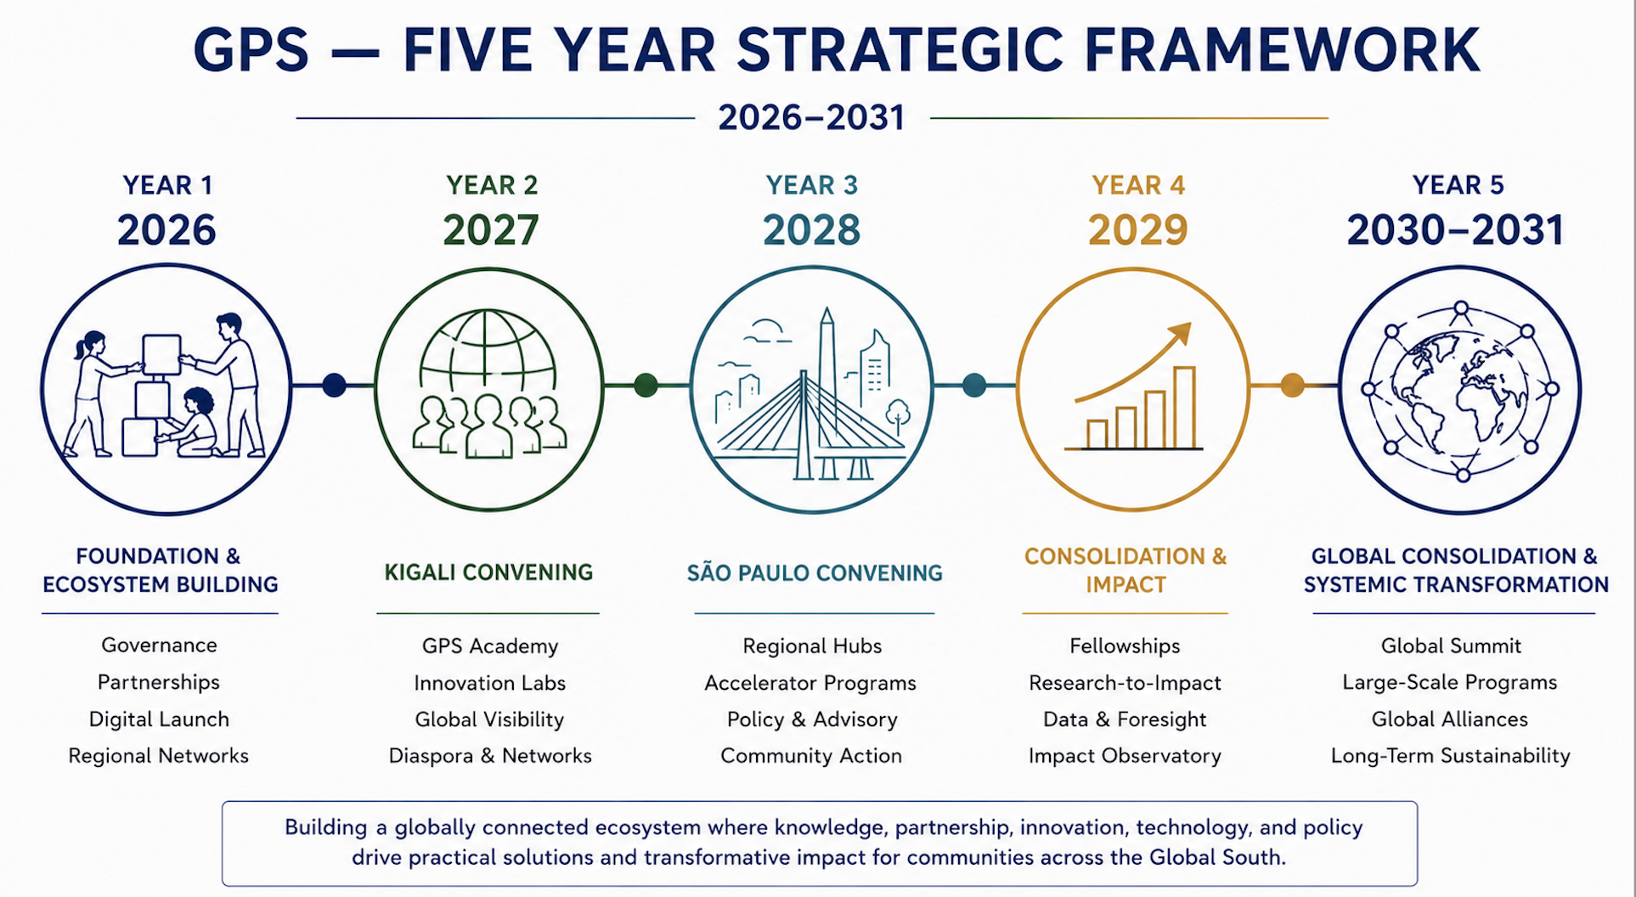

Suggested Activities (2026–2031)

LONG-TERM STRATEGIC OBJECTIVE
Over a five-year horizon, the Global Platform for the South (GPS) seeks to build a globally connected transdisciplinary ecosystem where knowledge, partnership, innovation, technology, and policy are placed at the service of practical solutions and transformative impact for communities across the Global South. Moving beyond an idea-based platform, GPS aims to become an influential institution capable of producing impactful knowledge, reframing narratives, strengthening leadership capacities, building strategic alliances, shaping policy agendas, advancing intellectual and epistemic plurality, and delivering sustainable and scalable initiatives throughout the Global South.
The following activities are designed to progressively transform GPS from an emerging platform into a globally recognized ecosystem connecting knowledge, policy, innovation, mobility, technology, implementation, and strategic cooperation across the Global South and beyond.

YEAR 1 (2026): FOUNDATION & ECOSYSTEM BUILDING

1. Institutional Structuring
Purpose: Build the institutional foundations necessary for credibility, coordination, and long-term sustainability.
Initiate the development of:
- governance model
- advisory councils
- regional hubs
- legal structures
- partnership frameworks
- institutional policies and operational systems

2. GPS Digital Launch
Purpose: Establish GPS as a visible and credible international platform.
Develop:
- official website
- visual identity
- communication systems
- social media platforms
- digital knowledge ecosystem
- multimedia and public engagement strategy

3. University Partnership Expansion
Purpose: Create a transcontinental ecosystem for collaborating institutions.
Formalize partnerships with:
- African universities
- GCUB member universities
- North American and European institutions
- strategic academic networks
- research and innovation centers

4. GPS Dialogues Series
Purpose: Create intellectual momentum before Kigali 2027.
Launch virtual and regional conversations on:
- education transformation
- AI and governance
- Indigenous and endogenous knowledge systems
- research and policy
- future of universities
- Global South cooperation and innovation

5. Institutional Sustainability & Resource Mobilization Strategy
Purpose: Build the long-term financial architecture necessary for institutional sustainability and implementation capacity.
Develop:
- fundraising strategy
- donor engagement framework
- strategic partnerships with foundations and development actors
- sponsorship architecture
- revenue-generating initiatives
- long-term endowment vision

6. Preparation of Kigali Knowledge Crossroads Week
Purpose: Transform Kigali 2027 into a global institutional milestone rather than a standalone conference.
Activities:
- thematic working groups
- scientific committees
- fundraising
- diplomatic outreach
- partnership agreements
- media and communications strategy

7. Strategic Expansion & Regional Hub Development
Purpose: Prepare GPS for long-term transregional growth and institutional presence across the Global South.
Initiate:
- exploratory partnerships in South Asia, the Middle East, the Caribbean, and Latin America
- consultations with universities and regional institutions
- identification of future locations for the regional hubs
- regional coordination frameworks
- diaspora engagement pathways

YEAR 2 (2027): GLOBAL POSITIONING & KIGALI EVENT

1. Kigali Knowledge Crossroads Week
Purpose: Launch GPS internationally as a major convening platform for the Global South.
Main components:
- GCUB General Assembly
- academic conference
- strategic workshops
- innovation showcases
- cultural and artistic programming
- policy dialogs
- technology and innovation exhibitions

2. Launch of GPS Outlook
Purpose: Position GPS as a producer of knowledge and narratives on the Global South.
Components:
- Annual Global South Outlook
- GPS Journal
- South Plus
- multimedia conversations
- podcasts and digital publications

3. Launch of GPS Academy
Purpose: Create long-term institutional and leadership ecosystems.
Activities:
- executive education
- leadership programs
- visiting scholars
- mobility initiatives
- South–South exchange programs
- policy and innovation trainings

4. Pilot Innovation Labs
Purpose: Connect research to experimentation and implementation.
Initial themes:
- AI and education
- climate resilience
- public policy innovation
- digital governance
- community-centered innovation

5. Diaspora & Global Networks Initiative
Purpose: Strengthen transnational collaboration and engagement between the Global South and its diasporas.
Activities:
- diaspora partnerships
- visiting experts and fellows
- transnational mentorships
- global networking platforms
- collaborative research and innovation initiatives

YEAR 3 (2028): IMPLEMENTATION & REGIONAL EXPANSION

1. São Paulo Convening (2028)
Purpose: Expand GPS influence into Latin America and strengthen transcontinental partnerships.
Focus:
- South–South innovation ecosystem
- university-industry collaboration
- entrepreneurship and technology
- applied research and implementation

2. Expansion of Regional Hubs
Purpose: Create a truly interconnected Global South ecosystem.
Potential development:
- Caribbean hub
- Middle East partnerships
- South Asia collaborations
- African and Latin American networks keep or leave expanded

3. GPS Accelerator Launch
Purpose: Translate ideas into scalable ventures and solutions.
Support:
- startups
- policy innovations
- educational innovations
- social enterprises
- technology-enabled solutions

4. Policy Advisory Programs
Purpose: Strengthen the link between knowledge and policymaking.
Work with:
- ministries
- universities
- cities
- regional institutions
- development agencies

5. Community-Based Implementation Initiatives
Purpose: Ensure that innovation and research translate into locally grounded impact.
Develop:
- community projects or pilots
- local innovation partnerships
- municipal collaborations
- participatory development initiatives

YEAR 4 (2029): CONSOLIDATION & IMPACT

1. GPS Fellowship Programs
Purpose: Build long-term intellectual and institutional networks.
Programs for:
- researchers
- policymakers
- artists
- practitioners
- emerging leaders

2. Research-to-Impact Initiatives
Purpose: Demonstrate measurable social and institutional impact.
Develop:
- implementation pilots
- community innovation programs
- policy experimentation models
- scalable demonstration projects

3. Global South Data & Foresight Platform
Purpose: Support evidence-based planning and decision-making.
Develop:
- dashboards
- analytics
- scenario-building tools
- strategic monitoring systems
- foresight and policy intelligence tools

4. Institutional Partnerships with Development Actors
Purpose: Strengthen sustainability and implementation capacity.
Collaborate with:
- development banks
- philanthropic foundations
- multilateral organizations
- private sector actors
- innovation and technology partners

5. GPS Impact Observatory
Purpose: Measure institutional influence, implementation outcomes, and policy impact.
Develop:
- impact indicators
- monitoring and evaluation systems
- policy tracking frameworks
- implementation assessment tools

YEAR 5 (2030–2031): GLOBAL CONSOLIDATION & SYSTEMIC TRANSFORMATION

1. GPS Global Summit
Purpose: Position GPS as a permanent international institution shaping conversations on knowledge, innovation, policy, and Global South cooperation.

2. Expansion of the GPS Global Ecosystem
Purpose: Deepen institutional presence and strategic partnerships across regions.
Activities:
- additional regional hubs
- city-to-city partnerships
- expanded university consortia
- strategic global alliances

3. Large-Scale Implementation Programs
Purpose: Scale successful pilot initiatives into transnational programs.
Potential areas:
- educational transformation
- AI governance
- climate adaptation
- digital inclusion
- innovation ecosystems
- community resilience

4. Global South Policy & Innovation Consortium
Purpose: Create permanent collaboration mechanisms between universities, governments, industry, civil society, and innovation ecosystems.

5. Long-Term Institutional Sustainability Strategy
Purpose: Ensure the continuity and global influence of GPS beyond its founding phase and space.
Components:
- endowment development
- long-term financing partnerships
- institutional investment strategy
- global fundraising architecture
- sustainability and growth planning

